Would You
Rather?!

Name: _________________________________

#1 Would you rather have a salary that is ½ of a million dollars per year or would you rather get paid $166,666.66 three times per year?

Option 1: | Option 2:

Explain your choice: ____________________________________________________________________ ____________________________________________________________________________________________________________________________________________________________________________________________________________________________________________________________________________________________________________________________________________________ _____________________________________________________________________________________

Correct Calculations | Clear Math Explanation | Clear Reason | Creativity
½ of a million = $500,000  3 x $166,666.66 = $499,999.98 | “I know that ½ a million dollars is $500,000 because I made a number line. I know half is in the middle of two numbers, so I could divide one million by two, which made me get $500,000.” | “When I compared the two numbers, I saw that ½ a million dollars is more than three times $166,666.66. I would rather have more money, so I chose ½ a million dollars.” | “With those extra two pennies, I could save up and maybe one day buy a gumball.”
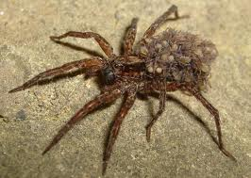
Would You
Rather?!

Name: _________________________________

#2 Would you rather have a snake sleep in your bed for 8 ½ hours or have a spider on your desk for 2/3 of the school day each day this week?

Option 1: | Option 2:

Explain your choice: ____________________________________________________________________ ____________________________________________________________________________________________________________________________________________________________________________________________________________________________________________________________________________________________________________________________________________________ _____________________________________________________________________________________
Correct Calculations | Clear Math Explanation | Clear Reason | Creativity
Option #1 = ______  Option #2 = ______ | Strategy Used:  *Number Line  *Converting Decimal to Fraction using Division  * Fraction Boxes  *Other? | One Example:  “When I compared the two numbers, I saw that _______________. I would rather have __________, so I chose __________________.” | Explain Your Reasons!  What YOU are thinking – it can be funny, clever, and wacky.
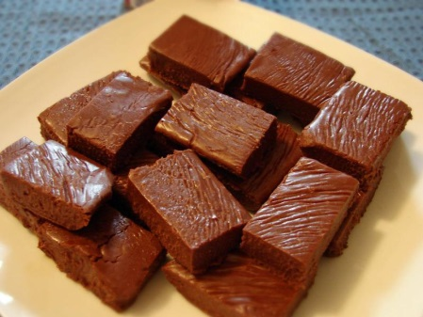
Would You
Rather?!

Name: _________________________________

#3 Would you rather get to eat 7/5 pounds of chocolate chip cookies or fourteen tenths of a pound of chocolate fudge?

Option 1: | Option 2:

Explain your choice: ____________________________________________________________________ ____________________________________________________________________________________________________________________________________________________________________________________________________________________________________________________________________________________________________________________________________________________ _____________________________________________________________________________________
Correct Calculations | Clear Math Explanation | Clear Reason | Creativity
Option #1 = ______  Option #2 = ______ | Strategy Used:  *Number Line  *Converting Decimal to Fraction using Division  * Fraction Boxes  *Other? | One Example:  “When I compared the two numbers, I saw that _______________. I would rather have __________, so I chose __________________.” | Explain Your Reasons!  What YOU are thinking – it can be funny, clever, and wacky.

Would You
Rather?!

Name: _________________________________

#3 Would you rather ________________________________________________ ______________________________________________________________________________________________________________________________________

Option 1: | Option 2:

Explain your choice: ____________________________________________________________________ ____________________________________________________________________________________________________________________________________________________________________________________________________________________________________________________________________________________________________________________________________________________ _____________________________________________________________________________________ _____________________________________________________________________________________

Would You Rather?!

Name: _____________________________________

Option 1: Seventeen tenths  hours in a pool filled with sharks | Option 2: One and seventy-  nine hundredths hours in a  cage with lions
Amount: ________________________________ | Amount: ________________________________

What would you choose:

Option 1: ¾ of an hour  changing dirty diapers | Option 2: 0.34 of an hour  shoveling mud.
Amount: ________________________________ | Amount: ________________________________

What would you choose:

Option 1: 87 thousandths | Option 2: 0.054
Amount: ________________________________ | Amount: ________________________________

What would you choose:

